Computer Science 5413-SD

Topics in Cloud Computing and Edge Co

WEB BASED ATTENDANCE MANAGEMENT SYSTEM

Project Proposal Document



Sai Surabhi Deepika – 0884203

Sanhith Reddy - 0889854

Sandeep Nannamu – 0882000

1. INTRODUCTION

Attendance Management System has started trending as a well known module for School Administration Program. Numerous Academic Institutions like School / Colleges are beginning to implement it nowadays. The framework makes a difference in keeping track record of students and staff every day attendance. In comparison to the manual attendance recording framework it is more vigorous and precise to form a successful attendance recording framework.

In the present day age of Information & Innovation it has become apparent for corporate companies and instructive establishments to work through Cloud based ERP Frameworks and diminish all the manual admin paperwork. This decreases the by and large turnaround working time on the given specific assignment or occasion. And certainly spares more time than ever. Nowadays, with the advancements within the innovation technologies, it has raised the level of administration work to the beat the benchmark standards. Lion's share of institutes are willing to apply for more School / College Management Administration Systen. In this way, the working strategies for admins within the school managements are changing and advancing in surprising ways.

A School / College attendance framework may be a School ERP Cloud Computer program that's utilized by instructors and School / College directors to keep track record of all the every day student's participation and institution staff individuals. The utilization of management framework for day by day participation notices is more vigorous and well known than the standard manual attendance process. The School / College Participation Administration Framework makes a difference by helping guardians and higher management to routinely check on the students participation status through real-time framework. In this way, improving the efficiency and productivity of the students. Such frameworks offer assistance to instructors and school admins to productively oversee and track normal attendance as well.

Storing students and faculty timesheets and attendance details in a centralized cloud-based attendance management system will:

* Ensure data integrity
* Improve productivity
* Enhance the efficiency of admin staff
* Reduce administrative work
* Increase accuracy
* Lower admin costs
* It streamlines the Overall General Attendance Procedure
* Manage attendance of all the students and staff from a single platform
* Proxy attendance can be greatly reduced

The main benefit of implementing this attendance management system in cloud is that various branches of an academic institution all over the country can utilize this centralized management system. It reduces the cost of maintaining and managing IT systems, saving a lot of time and effort. Operating costs such as hardware and software needs, system upgrades are greatly reduced.

2. SYSTEM REQUIREMENTS AND SPECIFICATIONS(SRS)

Functional requirements state how a system behaves when encountered with user inputs. A few of the functional requirements are stated below:

* Faculty and students can create their own account, update profile details, passwords etc
* Record attendance of students and faculty
* Check average attendance
* User interface that is implemented will be simple and easy to use.
* View attendance from anywhere around the globe

Some of the non-functional requirements include the following:

* Accuracy: Software should be accurate and should provide correct attendance results
* Availability: Software should always be available to a user
* Ease of Use: The application should be user friendly and easy to use
* Robustness: Speed of computation should be good
* Portability: Software should be able to work on many platforms.

3.1 SYSTEM REQUIREMENTS

System requirements include software, hardware requirements and the data source. These are mentioned below:

Website setup:

* Hardware requirements:

The minimum requirements for running the software are mentioned below.

Processor: Intel Core i3

RAM: 6 GB

Memory: 20 GB

* Software requirements:

Back end: Java, JDBC, Swing

Front end or user interface: html, xhtml, javascript, php and css

Operating System: Windows 8

Database: PHP, MySQL

* Server Requirements: XAMP server

Cloud setup:

* The website will be hosted using AWS Beanstalk/ Amazon EC2

4. PROPOSAL

In the academic institutions nowadays, student and faculty hours are more flexible than the fixed timetables of primary and secondary schools. And to coordinate those more adaptable participation hours, this attendance management system gives a more adaptable attendance framework to keep track of who is on location, where they final checked in, and indeed check their presence at a particular lecture.

5. FEATURES

The system is implemented as stages or different modules for better user friendly experience and maximum consistency. Below are a list of each module and its features.

Module 1: Student Module

* Create an account
* Update account password
* Can register for multiple lectures
* Check attendance for all the registered lectures
* View their attendance from anywhere around the globe
* Generate/Download report of attendance in pdf format
* Check average attendance

Module 2: Faculty Module

* Create an account
* Update account password
* View list of students assigned to them
* Mark attendance for each lecture
* Generate/Download report of attendance in pdf format
* Check average attendance
* Manage attendance of students in multiple lectures

8. ARCHITECTURE:

8.1 System Architecture and Implementation

The plan of implementation for the system is shown in the figure below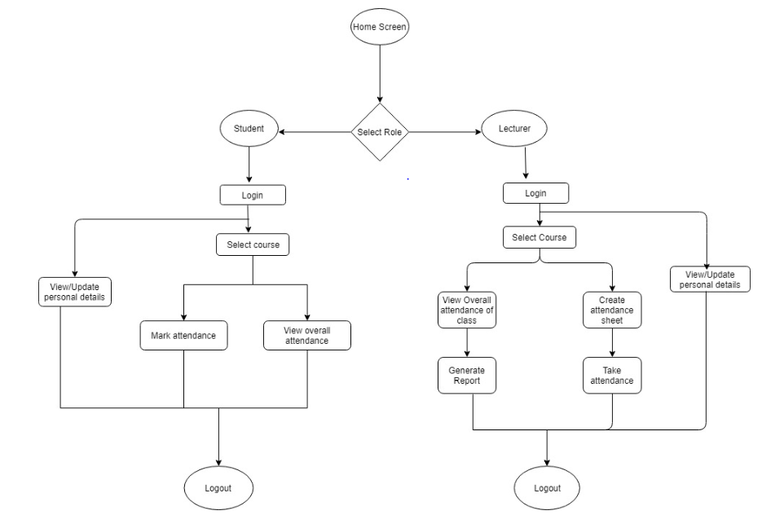

Figure 1: Design Flow

As shown in the figure, the website would begin with the home page. The home page will link to all important paths that a user can navigate to. The important pages that the home page is linked to are login pages for students and faculty, students profile, faculties profile, students attendance request, view attendance page, faculty’s attendance approval , view overall attendance pages and so on.

The overall flow is as follows:

Students and faculty must register into the system first. Registration is only possible if their details are already entered into the database by admin. The registration requests will be first sent to admin for approval. Faculty and students can login into the system only if the registration request is verified and approved by the admin.

There are three actors in this system. Their functionalities are mentioned below

Admin:-

1. Verify details and approve/reject registration requests
2. Update course schedules in the timetable

Student:-

1. Students select their profile as students and login
2. Students can view or update personal details
3. Select the registered course
4. Request for attendance by providing the details
5. View overall attendance for all the classes taken place till now
6. Logout

Faculty:-

1. Faculty select their profile as faculty and login
2. Faculty can view or update their personal details
3. Faculty can create an attendance sheet which the students can use to request attendance
4. View overall attendance of the class
5. Generate and download report
6. Logout

The use case diagram for the three actors in this system would be as shown below:

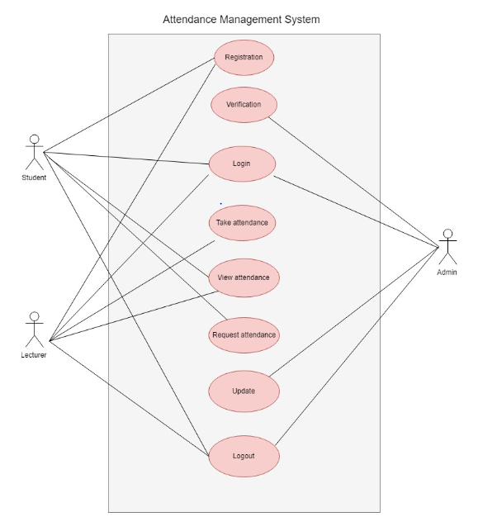

Figure 2: Use Case Diagram

8.2. **Database Structure**

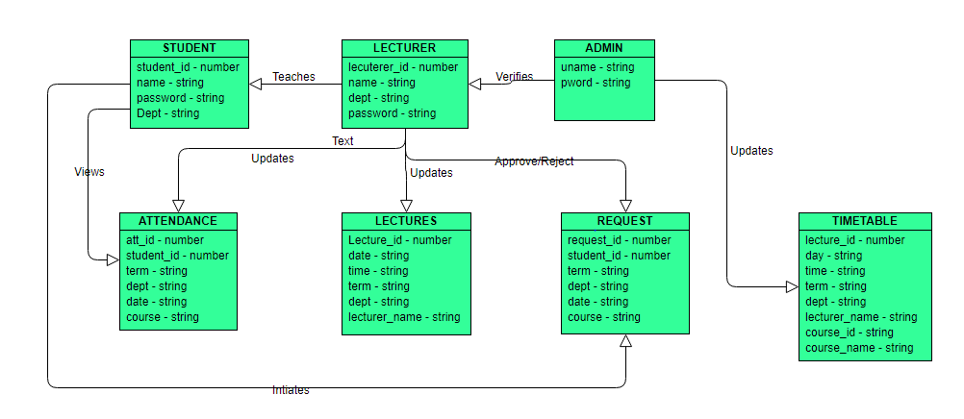

Fig 3: Class diagram for Attendance Management System

The complete system is very interactive and user friendly. It is divided into three modules and there are total seven tables in the database as shown above.

- There is many to many relationship between lecturer and student, student and request, lecturer and attendance, student and attendance

- There is one to many relationship between admin and lecturer, admin and student, admin and timetable

**9.2 DEVELOPMENT**

During our website development phase we will be coding the front end or the user interface (UI) in html, xhtml, css, javascript and php. For our backend programming, we will be using java and php programming. We will be using Eclipse as an interface for running these programs.

The database managed will be in SQL. The user specific information in the system, including the students and lecturers information will be stored in SQL.

There will be 2 phases in development. Phase 1 would be database design, website design, integrating backend and frontend to get a fully functional website. Phase 2 would include Deploying this website into a cloud service, namely the amazon AWS cloud service with the help of amazon EC2/Amazon S3.

9.3 TESTING

For testing we'll be utilizing both unit and integration testing at each stage in our program. Unit testing will be performed for examination of each and every functionality. Integration testing will be performed on interfaces to discover the bugs between modules or capacities. Once unit and integration tests are total, we'll be performing the end to end system testing of this application.

10. TIMEFRAME AND SCHEDULE

|  |  |  |  |  |
| --- | --- | --- | --- | --- |
| **TOPIC** | **START DATE** | **END DATE** | **NO OF DAYS** | **ROLE** |
| **OVERALL PROJECT** | 15-May | 4-Jun | 21 | ALL |
| **TOPIC and BACKGROUND RESEARCH** | 15-May | 17-May | 2 | ALL |
| **WEBSITE DESIGN ABD BACKEND INTEGRATION** | 18-May | 29-May | 12 | ALL |
| **DEPLOYING IN CLOUD** | 30-May | 2-Jun | 4 | ALL |
| **FINAL REPORT** | 3-Jun | 4-Jun | 2 | ALL |

11. GIT HUB LINK